Semiconductor Growth: Key Points
Optoelectronic Devices are prepared by epitaxy: the growth of one crystal layer on crystal substrate.
In most devices we must try to keep defects down.
There are two principal types: point defects and extended defects.
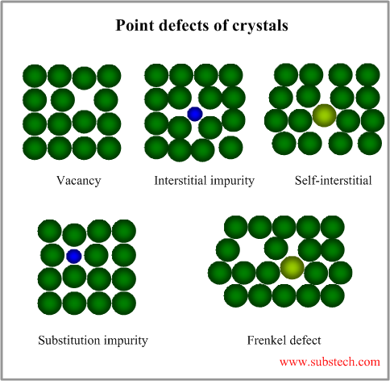
Point Defects are sites in the crystal lattice where there is:
- An undesirable impurity atom. These impurities include, oxygen atoms, carbon atoms, or atoms such as Copper or Iron. Oxygen and Carbon can be particularly difficult to control.
- A Vacancy. This is a crystal site where the atom is missing (e.g a site where we expect a Ga atom but there is not one. The gap is surrounded by dangling bonds.
- An Interstitial. This is an atom that associates itself loosely with an atom on a crystal site distorting its position in the lattice. The interstitial atom is usually very small: e.g. Hydrogen, Lithium. Example in p-type GaN Hydrogen associates with the Mg atom and the material must be heated to remove the Hydrogen from the crystal.
All of these defects induce states that are in the middle of the bandgap. These allow non-radiative recombination in the active region reducing the efficiency of an optoelectronic device. In doped layers the defects are scattering centres that can reduce the mobility of the electrons and holes.
To avoid these defects care must be taken to ensure the growth conditions are at the optimum temperature and that the ratio of group III and group V reactants is also optimised.
Extended Defects are essentially dislocations. Dislocations are lines in the material where the atoms do not line up correctly as a result of the need to reduce strain in the crystal. There are many types, but the key point is in most III-V materials not to let them form. In GaN we have no choice, so the aim is to minimize the density.
For III-V materials containing As, P, Sb a high quality substrate that has few dislocations running through it is used. Any dislocations in the substrate will carry on running up into the epitaxial layer during the growth. To stop any new dislocations forming the epitaxial layers must be kept to have the same lattice spacing as the substrate. If there is a “lattice mismatch” then if the layer is thin enough (such as a quantum well) it will remain strained. However once the thickness exceeds some critical value then it is energetically favourable for dislocations to form.
For III-nitride materials most material is grown on a mismatched substrate, which gives a high density of dislocations. Due to the strength of the chemical bonds and other factors (there are ways to engineer the sample so that the electrons and holes do not “fall” into the dislocations) unlike other III-Vs the sample can still show good luminescence. However, it is still needed to reduce the dislocation density as much as possible. We try to persuade the dislocations to bend over and interact with each other. Depending on the dislocation type dislocations when they meet can annihilate.
For both cases it is important to avoid getting new dislocations in the quantum well region as these are particularly detrimental to device performance. Dislocations again from states withing the bandgap which lead to non-radiative emission. In lasers (especially red lasers) the high intensity field in the device can cause dislocations to move and increase in size, a process which can rapidly degrade the device to the point where it fails.

Fabricating a device from a wafer.
Once we have a high quality wafer of material it needs to be processed into the device we wish. To achieve this we need to place contacts on the material, and we may also need to etch the sample away in certain locations. To achieve this the wafer is processes as a whole and then finally it is diced up into individual devices, placed in a package and then sold.

Photolithography
We saw when we discussed the extraction efficiency of an LED that we do not wish the metal contact to be everywhere, otherwise the light will not escape from the device. To achieve a selective metallisation we can use this process. A light sensitive layer, called a photoresist (or resist) is first spun onto the wafer to provide a coating. The spinning of the liquid ensures that the layer forms a uniform thickness across the wafer. This resist is then heated in an oven, evaporating the solvent left and forming a hard layer.
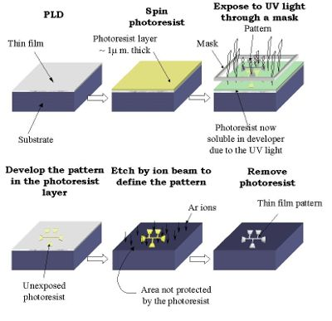
The sample is then exposed to light through a mask with black features on it. Where the light shines there is a chemical change (just as for photographic film), while areas under the black features remain the same. It is the high energy blue-violet and UV light that induces the change, so the whole of the process is carried out in a room with special lights, called a “yellow room”.
The sample is then placed in a “developer” solution and the areas not exposed to light dissolve away. (There are resists that do the opposite to this also), and in those areas the semiconductor surface is exposed for a treatment. This might be a metallisation or etching. Often the patterned resist is baked again to make it more resistant to the treatment processes we wish to apply to the exposed areas of the semiconductor.
After the treatment a solvent can be used to dissolve away the resist that is left and anything on top of that resist (e.g. metal) will be removed. The metal will only remain where it was placed in contact with the semiconductor.

Metallisation, or Metal deposition
There are two ways commonly used to evaporate metals onto a semiconductor surface. Thermal evaporation, and e-beam evaporation.
In thermal evaporation the metal that we wish to place on the surface is itself coated on a filament, such as tungsten. This is placed with the wafer in a vacuum chamber, Current is driven through the tungsten, heating it up, which causes the metal to evaporate from it at a known rate. A shutter is then opened exposing the sample to the flux of the metal for a fixed period of time to give a coating of the desired thickness.
In e-beam evaporation the metal we want to use for the contact is placed in a crucible. An electron beam is shone onto the centre of the crucible locally heating the metal till it evaporates and forms a flux hitting the sample. Once again the sample is in a vacuum chamber.
In many cases the best contacts require complex metal layer stuctures to get the best contact.
After deposition the semiconductor wafers are heated which causes interdiffusion between the layers and also into the semiconductor. This allows the formation of an ohmic contact with low resistance. The chemistry of the semiconductor metal interface is complex. Usually the best contacts are made by following some general principles, combined with careful empirical science.

Etching
In many cases we wish to selectively remove the topmost semiconductor layer from certain areas, perhaps to place an electrical contact to a lower layer. Another application is to make a waveguide for a laser diode. If we deposit a dielectric such as silicon dioxide on the surface we can selectively remove that also by a photolithography step followed by etching.
Etching can either be “wet” or “dry”. Wet etching involves immersing the sample in a suitable usually acid containing solution for a period of time. This will remove the dielectric or semiconductor material in the exposed areas. The amount of material dissolved can be given by the time it is immersed in the solution, or in many cases a “selective” etch is used which when it reaches a layer in the semiconductor structure of a certain composition the etch cannot penetrate as the compound is impervious to that etchant. This is called an etch stop layer. For example GaInP and GaAs have different chemicals that can remove one but not the other.
In dry etching the layers is placed in a vacuum chamber in which a plasma is formed, containing reactive species such as Chlorine or Fluorine. The exposed areas are etched by the plasma beam. Dry etching is more expensive, but is much more controllable, especially for small sized features where surface tension and other effects can be a problem

Dicing and Packaging
Once we have formed the device using etching and metallisation the wafer will usually be tested. If it is satisfactory it will be diced into small pieces. Usually the wafer is scratched along the easy breaking planes (e.g. the (110) planes we discussed last time) with a diamond tip (called a scribe) and the wafer then can be broken reliably and easily. In some cases the substrate is polished or etched down to reduce the thickness and make this easier. This may have other advantages as the thermal conductivity of most semiconductors is relatively poor compare to a metal.
The device will then be placed in a holder, such as the metal cup for the LEDs shown previously. A thin wire (often gold) is then attached to the metal contact on the semiconductor and to a metal pad that connects to the “pin” that current will be applied from. This process is called bonding. Metal bonding involves placing the wire on the pad and essentially melting the wire into it.
Additional packaging such as adding the resin lens or putting a protective glass cap on the package completes the process in making the device.

A real device process….
To give an idea of the complexity in practice in making an device, let us consider a simple blue LED.
GROWTH. First we need to get the LED cystal layers: Starting with a sapphire substrate we heat the sample in the MOVPE reactor and grow:
1) GaN buffer layer – to get a reduced dislocation density. 2) GaN:Si – n-type doped layer 3) Active region consisting of 5 quantum wells of InGaN (2 nm thick each) separated by GaN barriers. 3) GaN:Mg – p-type doped layer.
This sample is then removed from the reactor for WAFER PROCESSING.
Stage 1: The wafer is annealed (heated) in a nitrogen atmosphere to drive off the hydrogen sitting interstitially with the Mg dopants.
Stage 2: Spin a resist and pattern using photolithography. Dry etch the exposed material down to the n-type GaN layer. Remove all resist
Stage 3: Spin a resist and pattern using photolithography exposing only areas on the etched n-GaN surface. Deposit a metal contact containing Ti and Al layers. Remove resist. Anneal sample around 700ºC in Nitrogen to get good ohmic contact.
Stage 4: Spin a resist and pattern using photolithography exposing only areas on the p-GaN surface. Deposit a very thin (10 nm) metal layer of Ni followed by one of Au of similar thickness. Remove resist. Anneal sample in air to get a good “semi-transparent” ohmic contact.
Stage 5: Spin a resist and pattern areas on the n- and p- metal areas. Deposit locally a thick layer of Au to allow give us a contact bond pad. Remove resist.
Stage 6: Test the wafer with metal probes to check that the growth and processing is in specification. If so then scribe an array of lines on the sample surface and dice into 350 µm x 350 µm chips.
DIE PACKAGING
Stage 1: Mount chips individually into metal cups, Stage 2: Bond a wire between the cup and the n-contact pad on the sample. Stage 3: Bond a wire from a separate metal lead through to the p-contact bond pad on the device. Stage 4. Immerse in transparent resin, leave to harden and remove.

